H.T No
Regulations:
A15

Sreenidhi Institute of Science and Technology
(An Autonomous Institution)
Code No: 5CC57 Date: 09-Oct-2020 (AN)

B.Tech III-Year I-Semester External Examination, October - 2020 (Supplementary)
FUNDAMENTALS OF SIGNALS AND SYSTEMS (EEE)

Time: 2 Hours Max.Marks:75

Note: a) No additional answer sheets will be provided.
b) All sub-parts of a question must be answered at one place only, otherwise it will not be valued.
c) Missing data can be assumed suitably.

ANSWER ANY 5 OUT OF 8 QUESTIONS. EACH QUESTION CARRIES 15 MARKS.

1. | a) | Define and explain power and energy signals with examples. | [8M]
 | b) | Derive the expression for component C₁₂ of approximating the function f₁(t) in terms of f₂(t) over the interval (t₁, t₂) and also prove that the component C₁₂ becomes zero, if the f₁(t) and f₂(t) are orthogonal. | [7M]
2. | a) | Obtain the Fourier series of the following signal  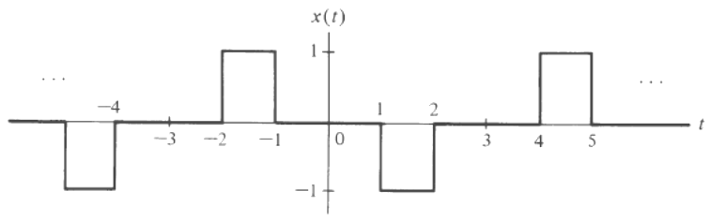 | [7M]
 | b) | State and prove the time Shifting and time Differentiation properties of Fourier Transform | [8M]
3. | a) | Check the following systems for causality and time invariane.  i) ii) | [8M]
 | b) | Discuss the filter characteristics of the ideal filters. | [7M]
4. | a) | Two subsystems and are connected in cascade. Using graphical interpretation of convolution find the overall transfer function | [8M]
 | b) | Find the Laplace Transform of the following periodic signal  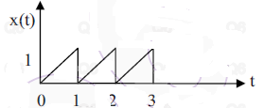 | [7M]
5. | a) | Determine the Nyquist sampling rate and Nyquist sampling interval for the following signals.  - x(t) = Sinc² (120πt)  - x(t) = rect(300t)  - x(t) = 10 sin(40πt) cos(300πt) | [9M]
 | b) | State and explain the ideal sampling theorem. | [6M]
6. | a) | Define ROC of Z-transform and list the properties of ROC of Z-transforms | [8M]
 | b) | Find the inverse z-transform of the following function  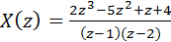; ROC: | [7M]
7. | a) | Derive the expression for computing Mean Square Error in approximating a function f(t) by a set of n orthogonal functions. | [8M]
 | b) | Find the Fourier transform of signum function. | [7M]
8. | a) | Derive the relation between auto-correlation function and Energy Spectral Density. | [8M]
 | b) | What is Aliasing or frequency folding effect? Explain. | [7M]

-- 00 -- 00 –

